1. Write a Program to Return Longest Integer SubArray

[-2, -3, 4, -1, -2, 1, 5, -3] with few test cases below

[ 1, 2, 3, 4]

[1, -2, -3, 5]

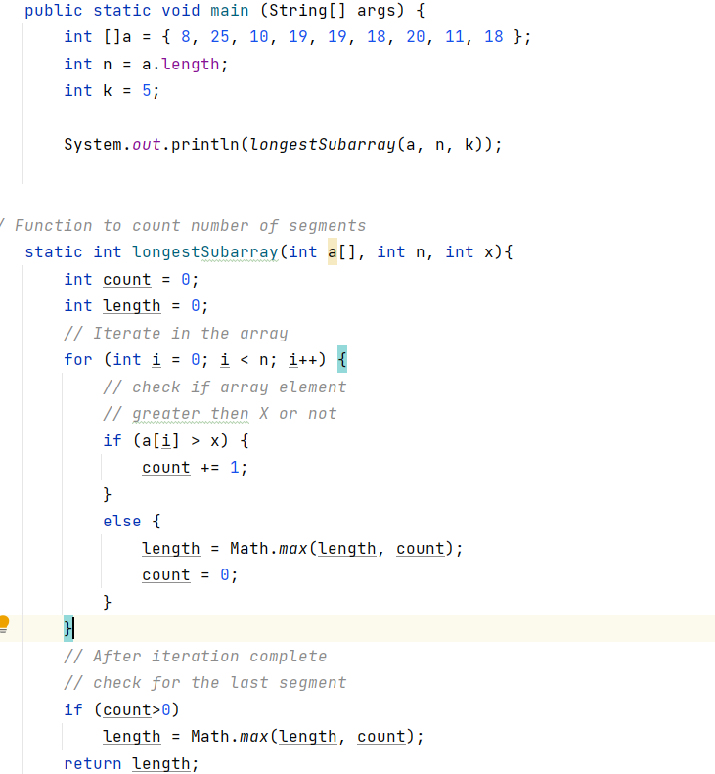

2. Which Functinal Interface Will Take 2 Parameters and Return Single Return Type.

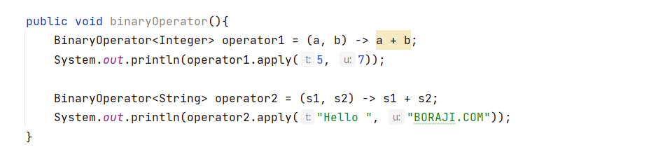

3. What is Lambda and why Should go for?

4. Write RestEndpoints with Single Resource Ex: Customer with All Crud Operations and REST Rules

5. How to Secure Rest Endpoints?

6. Write Lambda which will Take 2 Parameter and Return 1 value

Angular :

1. Communication Between Components

<https://www.thirdrocktechkno.com/blog/how-angular-components-communicate/>

2. How to Pass Data from parent to nth Child in Angular

<https://stackoverflow.com/questions/53450115/pass-data-from-parent-to-nth-child-in-angular-5>

3. what is ViewChild

Property decorator that configures a view query. The change detector looks for the first element or the directive matching the selector in the view DOM. If the view DOM changes, and a new child matches the selector, the property is updated.

4. EventEmitter

Use in components with the @[Output](https://angular.io/api/core/Output) directive to emit custom events synchronously or asynchronously, and register handlers for those events by subscribing to an instance.